1.96: a)

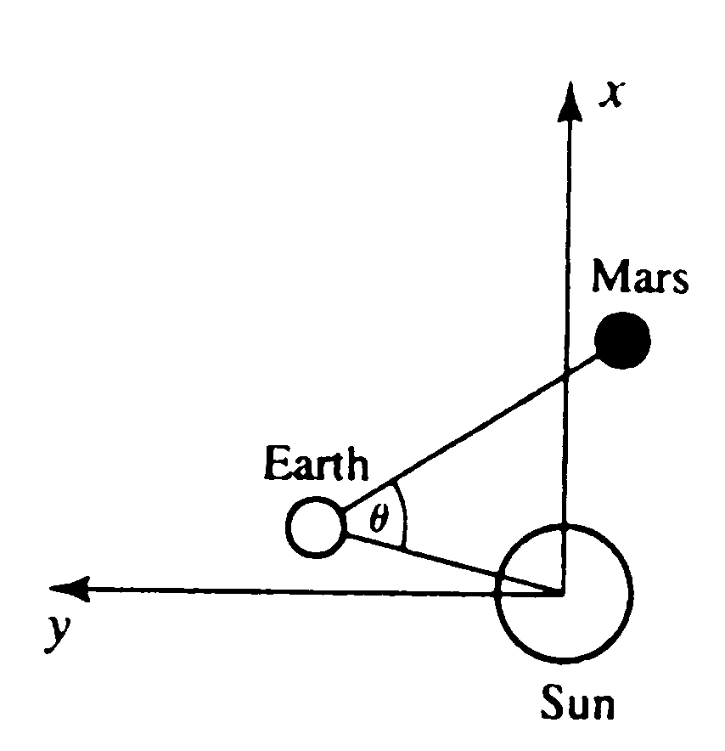

- i) In AU, 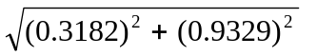 = 0.9857.
  - In AU, 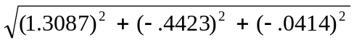 = 1.3820
  - In AU,

= 1.695.

- The angle between the directions from the Earth to the Sun and to Mars is obtained from the dot product. Combining Equations (1-18) and (1.21),

d) Mars could not have been visible at midnight, because the Sun-Mars angle is less than 90º.

